FREQUENTLY ASKED QUESTIONS

These FAQs offer only a simplistic explanation/clarification of terms/concepts related to preferential issue of shares under the SEBI (Issue of Capital and Disclosure Requirements) Regulations, 2018 [“ICDR Regulations, 2018”]. Any such explanation/clarification that is provided herein should not be regarded as an interpretation of law nor be treated as a binding opinion/guidance from the National Stock Exchange of India Limited. For full particulars of law governing the preferential issue of shares, please refer to the ICDR Regulations, 2018.

PART – I – In-principle application under regulation 28(1) of SEBI LODR, 2015

- What are the application stages involved in preferential issue of shares?

Trading Application
In principle Approval
Post Allotment Approval

- What are the important stages in preferential issue?
Company allots the securities
Company decides to come up with preferential issue
The Board of Directors approves the said issue subject to shareholders approval.
Company dispatches the notice and files the in-principle application with the Exchange(s) on the same day
333
2
1

6
5
4
Company files the in-principle listing / post allotment application with the Exchange(s) for Equity shares / Equity shares allotted on conversion of convertible securities
Company obtains in principle approval from the Exchange(s)

583333333333358358388
7
9

8
Company obtains the in-principle listing /post allotment approval from the Exchange(s)
Company files the trading application with the Exchange(s)
The Company initiates corporate action with the RTA & depository for credit confirmation letter

10
Company obtains trading approval

- What are the statutory timelines involved in preferential issue?
ICDR 2018 - Regulations | Timelines
Regulation 160 (f) - Application seeking in-principle approval to the stock exchange(s) | Application to be filed on the same day when the notice is dispatched to the shareholders
Regulation 162 (1) – Conversion period of convertible securities | Within 18 months from the date of their allotment.  Example: - In case the allotment is made on March 30, 2025, the convertible securities shall be exercise on or before September 29, 2026.
Regulation 162 (2) – Allotment pursuant to conversion | Allotment of equity shares pursuant to exercise of convertible securities including warrants is completed within 15 days from the date of such exercise.
Regulation 170 (1) – Allotment of specified securities | Within a period of 15 days from the date of passing of special resolution of shareholders’ approval or any approval or permission by any regulatory authority or stock exchanges, whichever is later
Schedule XIX - Para (2) of ICDR read with SEBI circular dated August 19, 2019* – Post allotment in-principle approval application to stock exchanges | Within 20 days from the date of allotment of securities
SEBI circular dated August 19, 2019* - Final trading approval application to stock exchanges | Within 7 working days from the grant of post allotment in-principle approval by stock exchange/s.
*SEBI circular dated August 19, 2019, https://www.sebi.gov.in/legal/circulars/aug-2019/non-compliance-with-certain-provisions-of-sebi-issue-of-capital-and-disclosure-requirements-regulations-2018-icdr-regulations-_43941.html

- How to determine relevant date in preferential issues?

30 days prior to Shareholder meeting date in terms of regulation 161

Shareholder meeting date
Example: April 10, 2025

For exp:
Relevant Date
Example: March 11, 2025

Notes w.r.t to relevant date

- If the relevant date falls on a weekend or a holiday, the day preceding the weekend, or the holiday will be reckoned to be the relevant date.

Example:
Particular | Date | Day | Remark
Shareholder Meeting Date | 15-Apr-25 | Tuesday
Minus 30 days | 16-Mar-25 | Sunday | Holiday
 | 15-Mar-25 | Saturday | Holiday
 | 14-Mar-25 | Friday | Holiday-Holi
Relevant Date | 13-Mar-25 | Thursday | Working day
Pricing Calculation to start from | 12-Mar-25 | Wednesday

Since the relevant date in the case above falls on a Sunday (holiday), the previous trading day is taken as relevant date as Friday & Saturday was holiday.

- In case of stressed assets under RBI or resolution plan under IBC, date of approval of such corporate debt restructuring package or resolution plan shall be the relevant date.

- What are the disclosure requirements w.r.t object of the issue, if the issue size of the preferential issue is more than INR 100 crores?

Exchange has been observing that company that the object of the issue as mentioned in the shareholders notice is vague and open-ended. Multiple objects are clubbed in a single object and an amount is allocated to such object. It is also observed that, the amount of the object is not properly quantified.

It is also observed that, under the interim use of proceeds, the Issuer mentions that during the pending utilization, the issue proceeds would be kept in equity, mutual funds (equity), to grant Inter-corporate deposits etc. which is not acceptable.

Based on the observations, Exchanges has already issued guidance note (Ref. No. NSE/CML/2022/56) issued on December 13, 2022, by NSE, the issuer shall ensure that they follow the guidelines prescribed below, while disclosing the object of issue in the explanatory statement to the notice of the shareholders:

- The purpose for which fund is proposed to be raised shall be disclosed under the separate heading “Object of the issue” in tabular format.

- Each object of the issue, for which funds are proposed to be raised shall be stated clearly and same shall not be open ended/ vague.

- The amount of funds proposed to be utilized against each of the object shall be stated clearly. In case, it is difficult to quantify the exact amount of fund to be used, a broad range of amount may be provided but the broad range shall be a realistic estimation and range gap shall not exceed +/- 10% of the amount specified for that object of issue size. Further, while giving broad range, the reason for providing the same shall be specified.

NSE Website Link:- https://nsearchives.nseindia.com//web/sites/default/files/inline-files/NSE_Circular_13122022.pdf

For Example:

The amount may vary +/- 10% due to________ (mention reason of such deviation).

For Example:
Table 1
Name of the Object | Amount (In INR Crores) | Tentative timeline for utilisation from the date of receipt of funds
Working Capital | 100 | 12 months
Repayment of Loan | 100 | 6 months
Capital Expenditure | 100 | 12 months
General Corporate Purposes | 50 | 12 months
- The above-mentioned objects are mere representation of the few objects. The Company shall give bifurcation under each object. The object should not be vague or open-ended. Multiple objects should not be clubbed in a single object.

- Total amount of issue size allocated for different objects of the issue shall together be used only for the object of the issue as specified in the placement document/ notice to shareholders and same cannot be added to General Corporate Purposes (GCP).

- The tentative timeline for utilization of issue proceeds for each of the object shall be clearly stated. Till such time the issue proceeds are fully utilized, the issuer shall also disclose the mode in which such funds will be kept.

For Example, for tentative utilization of issue proceeds the representation can be referred from Table 1 above.

The issue proceeds pending utilization shall not be kept in capital eroding instruments.

For interim use of funds, the Company may give the disclosure as follows:

“Pending utilization of issue proceeds, the fund shall be kept in a bank account with scheduled commercial bank or in any money market instruments.”

- The fund to be used for General Corporate Purposes (GCP), if any, shall not exceed 25% of the funds to be raised through the preferential issue, under the current issue.

- Common Observations with respect to the Objects of the Issue which are not acceptable.

1. | Clubbing of two or more objects in one object.
2. | Object not clear in term of end use.
3. | Object with contravention with other applicable laws.

- What happens in case of incomplete or incorrect disclosure in the explanatory statement to the notice for the general meeting of shareholders?

The Company is required to give disclosures in the explanatory statement as mandated in SEBI ICDR Regulations, 2018 (specifically Regulation 163) and guidance note, circulars and amendment thereof.

If incorrect or incomplete disclosures are given in the notice of shareholder’s meeting, such disclosures need to be corrected by the Company by issue of corrigendum prior to the start of e-voting.

Further, the Company should ensure that all the corrigendum related queries including any changes in the valuation should be intimated to the shareholders prior to the start of e-voting.

- What are the important points for the Company to be consider while preparing the shareholder notice?

- Disclosures as per Regulation 163

  - Object should be clear and not vague/open ended. In case the issue size exceeds 100 Crores guidance note (Ref. No. NSE/CML/2022/56) issued on December 13, 2022 should be duly complied with.
  - In intent of the promoters, directors and KMPs, the disclosure should clearly name the promoters, directors and KMPs participating in the proposed preferential issue.

If none of the promoters, directors and KMPs are participating in the preferential issue, the same shall be accordingly disclosed in the notice.

  - The shareholding pattern disclosed in the notice should be latest. The post shareholding pattern of the issuer should be provided on fully diluted basis.
  - The ultimate beneficial owner of the allottee should be disclosed except for those who have been provided exemption under the SEBI ICDR regulations, 2018.
  - The exact landing page of the PCS certificate as required under regulation 163(2) of SEBI ICDR Regulations, 2018 should be disclosed in the notice.
  - The exact landing page of the valuation report, if applicable, to be disclosed in the notice for shareholder meeting.
  - If there is change in control, guidance on control premium to be included in the valuation report.

- How to determine the period which should be considered for the calculation of issue price?

Pricing Calc to start from (1st Day)
April 08, 2025
Relevant Date
April 09, 2025
90th day preceding the relevant date November 29, 2024

- How is the ‘volume-weighted average market price’ of shares for a period of 90 trading days calculated under the ICDR Regulations 2018, in case of frequently traded shares ?

- The issuer shall consider VWAP for a period of 90/10 trading days by taking into consideration aggregate daily turnover in the scrip over the period of 90/10 trading days and dividing the same by the total number of shares traded during the said period.
- Kindly visit NSE - National Stock Exchange of India Ltd: Live Share/Stock Market News & Updates, Quotes- Nseindia.com website.
- Under Search Bar, mention the name of the Company and click on the same.
- Click on ‘Historical Data’ and select the series as BE and EQ for Main Board Companies and SM and ST for SME Companies.
- Enter the dates in the dates tab and click on Download (.csv) to generate the excel.

  - The below illustration calculates the 90 and 10 days VWAP for a particular Company.

S.NO. | DATE | SERIES | VOLUME | VALUE
1 | 29-Nov-24 | EQ | 52,44,346 | 9,75,41,22,115.25
2 | 02-Dec-24 | EQ | 28,68,263 | 5,36,05,64,446.55
3 | 03-Dec-24 | EQ | 47,15,792 | 8,91,92,59,125.80
4 | 04-Dec-24 | EQ | 47,05,573 | 8,91,77,17,924.90
5 | 05-Dec-24 | EQ | 90,50,038 | 17,42,17,67,118.35
6 | 06-Dec-24 | EQ | 35,73,331 | 6,86,63,14,025.75
7 | 09-Dec-24 | EQ | 42,74,645 | 8,17,49,59,449.55
8 | 10-Dec-24 | EQ | 61,74,921 | 12,02,30,85,384.00
9 | 11-Dec-24 | EQ | 50,25,612 | 9,89,15,78,979.60
10 | 12-Dec-24 | EQ | 64,62,130 | 12,85,46,35,035.90
11 | 13-Dec-24 | EQ | 53,62,693 | 10,64,70,66,758.55
12 | 16-Dec-24 | EQ | 31,19,221 | 6,19,28,34,340.70
13 | 17-Dec-24 | EQ | 58,11,050 | 11,45,85,71,096.45
14 | 18-Dec-24 | EQ | 30,64,095 | 6,05,49,11,475.20
15 | 19-Dec-24 | EQ | 53,23,592 | 10,33,16,27,136.20
16 | 20-Dec-24 | EQ | 1,10,56,720 | 21,36,76,88,611.40
17 | 23-Dec-24 | EQ | 27,81,793 | 5,35,10,92,778.15
18 | 24-Dec-24 | EQ | 23,60,544 | 4,52,89,21,027.25
19 | 26-Dec-24 | EQ | 36,23,321 | 6,91,34,42,832.95
20 | 27-Dec-24 | EQ | 39,37,500 | 7,52,87,76,747.25
21 | 30-Dec-24 | EQ | 77,89,055 | 14,82,47,04,664.65
22 | 31-Dec-24 | EQ | 36,13,063 | 6,76,64,28,350.50
23 | 01-Jan-25 | EQ | 18,38,368 | 3,46,52,23,831.85
24 | 02-Jan-25 | EQ | 70,83,645 | 13,77,42,39,233.15
25 | 03-Jan-25 | EQ | 62,18,003 | 12,04,13,66,929.80
26 | 06-Jan-25 | EQ | 71,64,403 | 13,92,59,86,567.85
27 | 07-Jan-25 | EQ | 42,94,832 | 8,31,59,96,332.75
28 | 08-Jan-25 | EQ | 54,82,050 | 10,50,43,91,305.45
29 | 09-Jan-25 | EQ | 68,33,503 | 13,17,58,34,552.90
30 | 10-Jan-25 | EQ | 80,36,913 | 15,76,18,35,256.95
31 | 13-Jan-25 | EQ | 58,04,152 | 11,41,01,82,349.85
32 | 14-Jan-25 | EQ | 57,92,162 | 11,25,94,72,879.00
33 | 15-Jan-25 | EQ | 29,85,439 | 5,81,90,96,239.50
34 | 16-Jan-25 | EQ | 75,33,579 | 14,61,04,85,616.25
35 | 17-Jan-25 | EQ | 1,64,09,953 | 29,93,46,01,377.85
36 | 20-Jan-25 | EQ | 43,33,011 | 7,84,00,06,233.80
37 | 21-Jan-25 | EQ | 71,69,109 | 13,00,65,82,697.55
38 | 22-Jan-25 | EQ | 83,73,913 | 15,46,26,99,193.55
39 | 23-Jan-25 | EQ | 59,07,471 | 11,04,03,65,439.10
40 | 24-Jan-25 | EQ | 48,87,027 | 9,19,52,42,026.10
41 | 27-Jan-25 | EQ | 76,52,371 | 14,06,57,47,508.90
42 | 28-Jan-25 | EQ | 69,99,495 | 12,89,61,53,068.90
43 | 29-Jan-25 | EQ | 51,45,155 | 9,60,61,85,635.05
44 | 30-Jan-25 | EQ | 73,36,056 | 13,64,21,83,045.25
45 | 31-Jan-25 | EQ | 58,20,470 | 10,95,11,49,690.20
46 | 01-Feb-25 | EQ | 17,01,402 | 3,16,87,63,954.00
47 | 03-Feb-25 | EQ | 48,23,228 | 8,96,45,53,565.40
48 | 04-Feb-25 | EQ | 73,34,787 | 13,87,97,56,408.55
49 | 05-Feb-25 | EQ | 49,96,744 | 9,50,27,54,311.35
50 | 06-Feb-25 | EQ | 47,65,255 | 9,10,47,91,357.40
51 | 07-Feb-25 | EQ | 41,26,260 | 7,84,99,62,358.05
52 | 10-Feb-25 | EQ | 38,28,734 | 7,22,05,70,924.25
53 | 11-Feb-25 | EQ | 44,11,601 | 8,31,00,66,406.30
54 | 12-Feb-25 | EQ | 56,33,947 | 10,51,69,84,029.10
55 | 13-Feb-25 | EQ | 52,37,744 | 9,69,61,50,378.65
56 | 14-Feb-25 | EQ | 52,92,961 | 9,76,58,18,737.55
57 | 17-Feb-25 | EQ | 44,28,956 | 8,14,32,13,452.30
58 | 18-Feb-25 | EQ | 43,65,260 | 8,07,05,46,827.05
59 | 19-Feb-25 | EQ | 46,11,411 | 8,39,65,92,012.20
60 | 20-Feb-25 | EQ | 22,18,020 | 4,04,18,74,473.40
61 | 21-Feb-25 | EQ | 33,79,879 | 6,14,31,29,066.35
62 | 24-Feb-25 | EQ | 75,94,720 | 13,41,78,27,673.25
63 | 25-Feb-25 | EQ | 50,92,963 | 8,99,47,61,660.15
64 | 27-Feb-25 | EQ | 57,57,079 | 10,15,21,84,052.30
65 | 28-Feb-25 | EQ | 1,21,82,167 | 20,64,31,37,452.85
66 | 03-Mar-25 | EQ | 75,04,969 | 12,84,14,55,573.45
67 | 04-Mar-25 | EQ | 67,59,673 | 11,39,77,44,323.60
68 | 05-Mar-25 | EQ | 81,80,782 | 14,02,60,24,448.60
69 | 06-Mar-25 | EQ | 1,06,10,547 | 18,14,03,99,842.70
70 | 07-Mar-25 | EQ | 80,19,331 | 13,52,31,83,544.05
71 | 10-Mar-25 | EQ | 75,58,981 | 12,87,40,09,178.00
72 | 11-Mar-25 | EQ | 1,26,71,234 | 20,97,17,94,102.35
73 | 12-Mar-25 | EQ | 1,48,70,008 | 23,59,13,64,599.50
74 | 13-Mar-25 | EQ | 78,22,888 | 12,37,82,47,563.85
75 | 17-Mar-25 | EQ | 75,26,032 | 11,90,39,59,172.65
76 | 18-Mar-25 | EQ | 62,98,054 | 10,09,21,66,910.70
77 | 19-Mar-25 | EQ | 73,87,068 | 11,69,47,51,809.10
78 | 20-Mar-25 | EQ | 71,86,750 | 11,61,60,04,800.30
79 | 21-Mar-25 | EQ | 1,00,74,677 | 16,03,22,62,527.35
80 | 24-Mar-25 | EQ | 88,57,726 | 14,07,28,23,625.15
81 | 25-Mar-25 | EQ | 98,90,140 | 16,08,22,64,118.35
82 | 26-Mar-25 | EQ | 66,51,302 | 10,71,37,71,940.10
83 | 27-Mar-25 | EQ | 94,26,573 | 15,09,58,08,795.90
84 | 28-Mar-25 | EQ | 67,99,047 | 10,71,81,60,396.85
85 | 01-Apr-25 | EQ | 1,26,80,733 | 19,39,40,47,386.75
86 | 02-Apr-25 | EQ | 61,93,478 | 9,58,18,59,877.35
87 | 03-Apr-25 | EQ | 1,04,59,504 | 15,68,70,69,999.20
88 | 04-Apr-25 | EQ | 95,90,254 | 13,98,88,55,633.45
89 | 07-Apr-25 | EQ | 2,17,15,252 | 29,64,62,33,824.90
90 | 08-Apr-25 | EQ | 1,28,05,001 | 18,38,44,91,521.00
 |  |  | VOLUME | VALUE
Sum for 90 days |  |  | 59,83,61,500 | 10,54,28,72,91,052.10
Sum for 10 days |  |  | 10,62,11,284 | 1,59,29,25,63,493.85
 | VWAP = Sum of Value/Sum of Volume
 | Price for 90 days |  | 1761.957096
 | Price for 10 days |  | 1499.770622

- Is Category-I Merchant Banker or Registered Valuer is required as per Regulation 163(3) of the SEBI ICDR Regulations, 2018 for swap of shares?

Valuation is required from the Independent Registered Valuer in terms of proviso to regulation 163(3) of SEBI ICDR Regulations, 2018.

- Is it mandatory for every issuer to obtain a valuation report from a registered valuer?
The Company should obtain the valuation report from a registered valuer in the following cases:
- In cases of infrequently traded shares
- If AOA requires valuation report to be taken
- Change in control or allotment of more than 5% of the post issue fully diluted share capital to an allottee or Person acting in concert.
- Swap of shares

The Valuer should provide the rationale for opting a particular method of valuation. The Valuer should also provide the rationale for assigning weights to different methods used in valuation.

- What are the common observations by the Exchange when it comes to the review of valuation report?
The following are the common observations by the Exchange for the valuation report:
- All the methods of valuation not taken in the valuation report.
- Rationale for different weights not given properly. Exp: More weight given to the method which gives least price.
- In DCF method, the projections taken are not in consonance with the previous financial performance of the Company. The projections are unrealistic.
- In case of swap of shares, the valuation of Company being acquired is not provided.
- In cases of swap of shares, the valuation of the company being acquired is not realistic basis the business and financial performance of the business.
- The Company states ‘price sensitive information’ for not opting DCF method.
Regulation 166A (allotment of more than 5% to person or persons acting in concert) applicability is not interpreted correctly by the Company and valuation report is provided even in cases where it is not applicable.

- What would be the lock-in treatment for pre-preferential holding?

In case of equity, the pre-preferential holding should be under lock-in starting from the relevant date up to a period of 90 trading days from the date of trading approval.

In case of warrants/convertible securities, the pre-preferential holding should be under lock-in starting from the relevant date up to a period of 90 trading days from the date of allotment of warrants or other convertible securities.

Type of security | Lock-in start date as per Reg 167 (6) | Lock-in end date as per Reg 167 (6)
Equity | Relevant date | 90 trading days from the date of trading approval*
Convertible securities or warrants if not listed | Relevant date | 90 trading days from the date of allotment of such securities

*Note:
- Tentative date to be considered
- Extend the lock-in in case of any shortfall to comply with regulation 167(6)
- Confirmation to stock exchange shall be provided in this regard

- What shall be the treatment of equity shares bought during the period of relevant date and date of allotment of securities?

The equity shares bought during the period of relevant date and date of allotment of securities, should be locked in in terms of regulation 167(6) of SEBI ICDR Regulations, 2018 (as mentioned in the point above) with immediate effect.

- What happens when an Allottee buys and sells his shares in intra-day trade during the period of lock-in?

The shares should not be sold/transferred 90 trading days prior to the relevant date in terms of regulation 159 (1) of SEBI ICDR Regulations, 2018 and from the relevant date the shares are to be kept under lock-in in terms of regulation 167(6). The sale by the allottee during the period 90 trading days prior to the relevant date would make him/her in-eligible to participate in the preferential issue.

The sale of shares between the relevant date and the period for which pre-preferential holding was supposed to be under lock-in would be considered as non-compliance on part of the Company.

The Company shall sensitize the Allottee to not sell any securities during the period of 90 days prior to the relevant date in terms of regulation 159 (1) of SEBI ICDR Regulations, 2018 and from the relevant date till the period pre-preferential holding is supposed to be under lock-in. The Company shall obtain an undertaking from the Allottee that he/she would not sell shares as directed to him/her in accordance with applicable laws.

- While applying for post allotment listing approval the demat statements of shareholders do not show lock in release date of the pre-preferential holding especially in case of CDSL. Please advise what proof can company submit in such situation for reflecting lock in release date for the pre-preferential holder.

The Company is required to provide transaction statement starting from the relevant date till the date of allotment of securities clearly reflecting the lock-in end date issued by the depository participant.
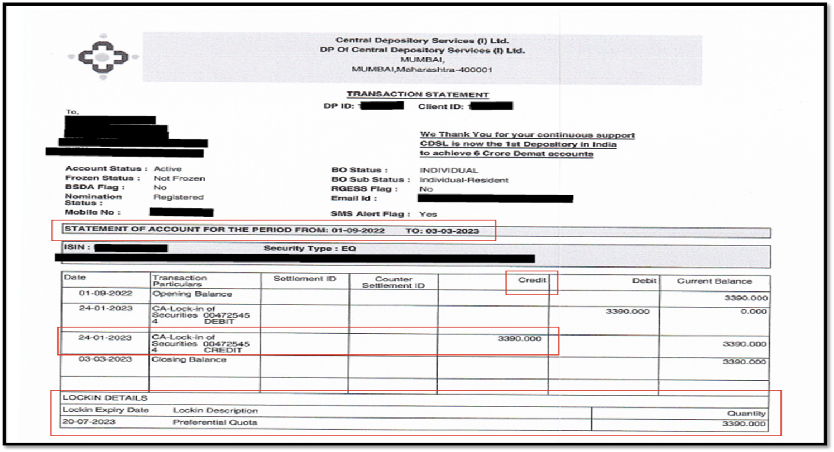
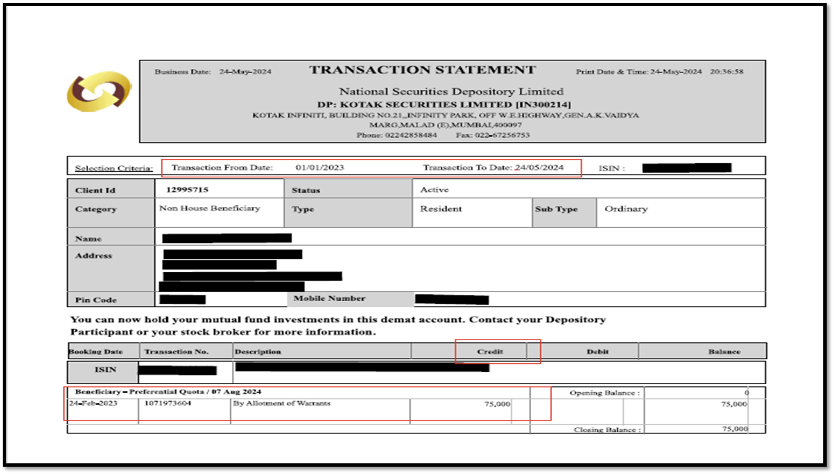

If the Company is not able to provide the transaction statement as mentioned above, the Company can provide the screenshot of the depository system clearing reflecting the name of the allotee, the number of shares, period, quantity of shares under lock-in and lock-in certified by the authorized signatory of the Company.
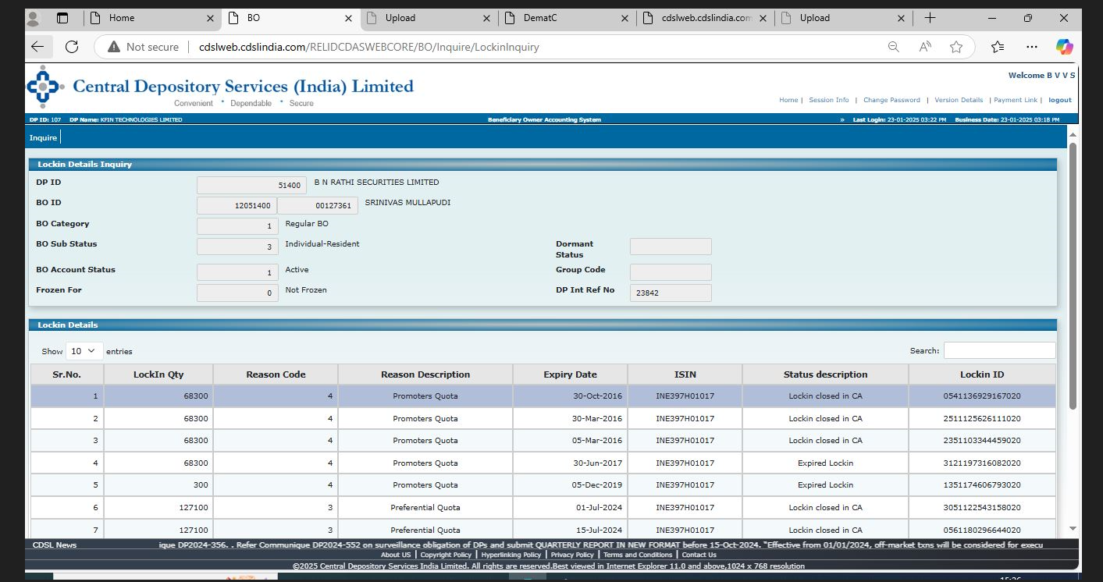+

- In case of convertible securities or warrants which are not listed on stock exchanges, such securities shall be locked in for a period of one year from the date of allotment. Can such securities be transferred after the expiry of one-year lock-in?
The specified securities allotted on a preferential basis shall not be transferable by the allottees till the trading approval is granted for such securities by all the recognised stock exchanges where the equity shares of the issuer are listed as per Regulation 168 (2) of the SEBI ICDR Regulations, 2018.
The warrants are kept under lock-in for a period of one year from the date of allotment. The question raised by the Stakeholders is that can warrants be transferred when the lock-in of one year expires? With regards to this, SEBI has provided guidance through an informal guidance.
As per SEBI Informal guidance dated November 10, 2023 in the case of Paramount Communications Limited has provided guidance on the above subject matter and as per the guidance the warrants shall not be transferable by the allottees till the trading approval is granted for such securities.

- Do we need to keep convertible securities or warrants in demat mode which are not going to list on Exchange(s) platform?

Yes. As per Regulation 170 (4) of SEBI ICDR states “Allotment of the specified securities shall be made only in dematerialised form.” In view of the same, the company has to initiate the demat and lock-in process with RTA and depository for convertible securities or warrants.

- When does the company have to make public announcement for an open offer?
As per Regulation 13(g) of SEBI (SAST) Regulations, 2011, The public announcement pursuant to an acquirer acquiring shares or voting rights in, or control over the target company, under preferential issue, shall be made on the date on which the board of directors of the target company authorises such preferential issue.

PART – II – In-principle Listing application (Post Allotment Application)

- What are the statutory timelines involved in preferential issue?
ICDR 2018 - Regulations | Timelines
Regulation 162 (1) – Conversion period of convertible securities | Within 18 months from the date of their allotment.
Regulation 162 (2) – Allotment pursuant to conversion | Allotment of equity shares pursuant to exercise of convertible securities including warrants is completed within 15 days from the date of such exercise.
Regulation 170 (1) – Allotment of specified securities | Within a period of 15 days from the date of passing of special resolution of shareholders’ approval or any approval or permission by any regulatory authority or stock exchanges, whichever is later
Schedule XIX - Para (2) of ICDR read with SEBI circular dated August 19, 2019 – Post allotment in-principle approval application to stock exchanges | Within 20 days from the date of allotment of securities
Final trading approval application to stock exchanges | Within 7 working days from the grant of post allotment in-principle approval by stock exchange/s.

- What are the observations when it comes to Statutory Auditor Certificate?

The statutory certificate has to be provided strictly in the format as mentioned in Annexure - I of the post allotment checklist of NSE.

With respect to point no. 2 of the Statutory Auditor certificate,

Consideration of [ Amount in Rs. of Equity shares OR Amount 25% of the entire warrants allotted in preferential issue + 75% of the warrants converted in to equity shares in current application] (specified securities), paid in cash, has been received from respective allottee's bank account and the relevant documents thereof are maintained by the _______[name of the Issuer] as on the ______ (date of certification).

The date of certification as mentioned in point 2 mentioned above should be same with the date on which the certificate is signed by the Auditor.

In case of conversion of loan into Equity shares, the certificate shall clearly specify the outstanding loan amount against which the allotment of Equity shares is made.

- What would be the lock-in treatment for pre-preferential holding?

In case of equity, the pre-preferential holding should be under lock-in starting from the relevant date up to a period of 90 trading days from the date of trading approval.

In case of warrants/convertible securities, the pre-preferential holding should be under lock-in starting from the relevant date up to a period of 90 trading days from the date of allotment of warrants or other convertible securities.

Type of security | Lock-in start date as per Reg 167 (6) | Lock-in end date as per Reg 167 (6)
Equity | Relevant date | 90 trading days from the date of trading approval*
Convertible securities or warrants if not listed | Relevant date | 90 trading days from the date of allotment of such securities

*Note:
- Tentative date to be considered
- Extend the lock-in in case of any shortfall to comply with regulation 167(6)
- Confirmation to stock exchange shall be provided in this regard

- What shall be the treatment of equity shares bought during the period of relevant date and date of allotment of securities?

The equity shares bought during the period of relevant date and date of allotment of securities, should be locked in in terms of regulation 167(6) of SEBI ICDR Regulations, 2018 (as mentioned in the point above) with immediate effect.

- When the Statutory Auditor's report is to be obtained in case of swap of shares?

The Statutory Auditor certificate is to be submitted during the post allotment cases as the same is the checklist requirement. The Statutory Auditor certificate should brief the swap transaction and the date when shares are transferred. The certificate should be in line with the format as provided in Annexure-I of the post allotment checklist.

- What would be the Lock-in of specified securities or equity shares allotted pursuant to exercise of the option attached to warrant?

Proposed allottee | Shares allotted in the proposed issue
Promoter/Promoter Group – 20% of the total capital of the issuer | 18 months from the date of trading approval
Promoter/Promoter Group – excess of 20% of the total capital of the issuer | 6 months from the date of trading approval
Non-promoters | 6 months from the date of trading approval

- In case of allotment of convertible securities, any additional step to be taken by companies to ensure compliance with various provisions of SEBI ICDR Regulation by the allottees?

Regulation 162 (1) of SEBI ICDR Regulation, inter alia, states the tenure of the convertible securities of the issuer shall not exceed eighteen months from the date of their allotment.

Also, as per Regulation 169 (3) of SEBI ICDR Regulation, in case the warrant holder does not exercise the option for equity shares against any of the warrants held by the warrant holder, the minimum consideration paid in respect of such warrant shall be forfeited by the issuer.

Additionally, as per Regulation 159 (2) of SEBI ICDR Regulation where any person belonging to promoter(s) or the promoter group has previously subscribed to warrants of an issuer but has failed to exercise the warrants, the promoter(s) and promoter group shall be ineligible for issue of specified securities of such issuer on preferential basis for a period of one year from:

a) the date of expiry of the tenure of the warrants due to non-exercise of the option to convert; or
b) the date of cancellation of the warrants, as the case may be.

In view of the above, to avoid auto-lapse of any convertible securities including warrants, the companies are advised to provide advanced intimation to the allottees w.r.t. forthcoming expiry of tenure of the convertible securities, giving sufficient time to allottees to convey their decision w.r.t conversion.

- Important Circulars for reference:

- Guidance notes on inclusion of "object of the issue" in case of preferential issue and in Qualified institutions placement – NSE circular ref. No. NSE/CML/2022/56 dated December 13, 2022.
https://nsearchives.nseindia.com//web/sites/default/files/inline-files/NSE_Circular_13122022.pdf

- To determine Ultimate Beneficial Owner - SEBI Circular CIR/MIRSD/2/2013 dated January 24, 2013 - https://www.sebi.gov.in/legal/circulars/jan-2013/guidelines-on-identification-of-beneficial-ownership_24206.html and SEBI Circular CIR/IMD/FPIC/CIR/P/2018/131 dated September 21, 2018 - https://www.sebi.gov.in/legal/circulars/sep-2018/know-your-client-requirements-for-foreign-portfolio-investors-fpis-_40408.html .

- Monetary fines in case of non-compliance of Chapter V of SEBI ICDR Regulations 2018 - SEBI circular SEBI/HO/CFD/DIL2/CIR/P/2019/94 dated August 19, 2019 - https://www.sebi.gov.in/legal/circulars/aug-2019/non-compliance-with-certain-provisions-of-sebi-issue-of-capital-and-disclosure-requirements-regulations-2018-icdr-regulations-_43941.html .

- Contact details of officials handling preferential issues:

The Contact details of the officials can be found at: NEAPS> Help> Contact Us > Approval> Further Issue (Pre & Post Allotment)

